A. IP Traffic Analysis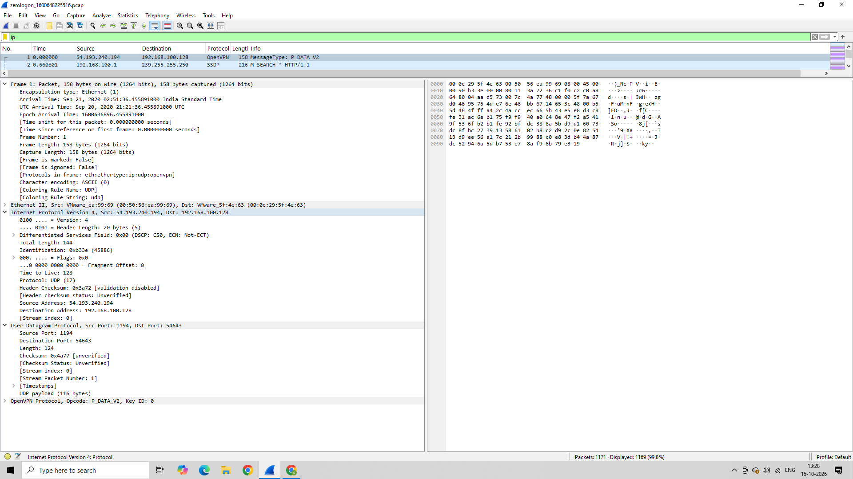
B. DNS Analysis
The dns filter displayed zero packets. No DNS packets were visible with this filter in the provided capture. 